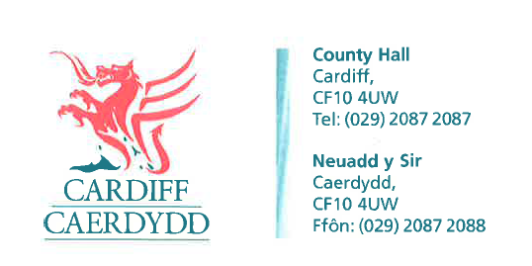
FOI Response Document
FOI08895
Thank you for your request under the Freedom of Information Act 2000 about Cardiff Metro - Demolitions received on 5th September 2016.
I am writing this email in relation to the Cardiff LDP and wider transportation plans which includes future Cardiff Metro.
1) What are the proposed timescales for further consultation and development of plans relating to extension of the City Line and reopening of the old railway line?
2) Have the individual houses that would be affected in Fairwood Close and Kirton Close been identified?
We have considered your request and enclose the following information:
There are no plans at present to extend the rail extension in this way and there are no plans to remove any houses.
If you have any queries or concerns, please do not hesitate to contact us.
Please remember to quote the reference number above in any future communications.

